Point-to-Point Protocol (PPP)

1. PPP is a data link layer protocol.
2. PPP is a WAN protocol which is commonly run over Internet links.
3. It is widely used in broadband communications having heavy loads and high speeds.
4. It is used to transmit multiprotocol data between two directly connected (point to point) computers.

Frame format:

1. 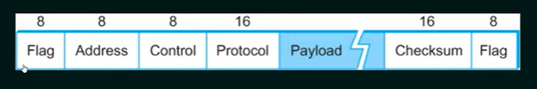
2. Flag: 1 byte that marks the beginning and the ne of the frame. The bit pattern of the flag is 01111110
3. Address: 1 byte which is set to 11111111 in case of broadcast.
4. Control: 1 byte set to a constant value of 11000000
5. Protocol: 1 or 2 bytes that5 define the type of data contained in the payload field.
6. Payload This carries the data from the network layer. The öaximum length of the payload of the payload field is 1500 bytes. However, this may be negotiated between the endpoints of communication.
7. Checksum: Error detection

Character stuffing (Byte stuffing)

1. Is the process of adding one extra byte whenever there is a flag sequence appearing in the payload.
2. Receiver will construct the data again by removing the extra byte.